**ASSIGNMENT-7**

**Name: Rayapati Naga Hema Chandrika Sravani**

**Reg ID: SIRSS1210**

1)Create a file via touch and update that file and also verify the timestamp and output will be redirected to another file?

A)

* First we have Created a new directory d1 using 'mkdir'.
* Go to that directory using "cd" command.
* Use touch command to create a file and check the details of file using ls command.
* we can write the data into the file using 'cat' command.
* Update the time stamp of the file created using touch command and check it using 'ls-l'.

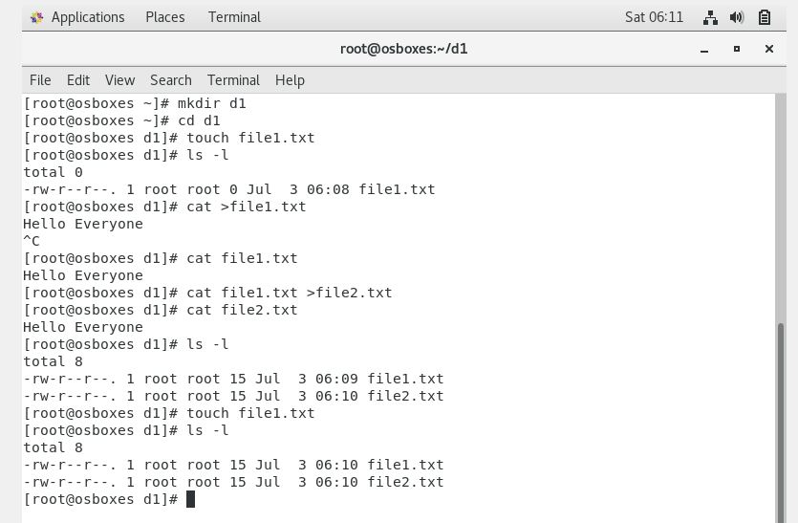

2)Add some of the data as per your choice and append that data via echo command in the same file Install httpd and set up your own web server?

A)

* Open a file using vi command .
* Go to insert mode to write something.
* After writing data press "ESC" key on keyboard and type "wq" and hit "enter" key for quitting the file and save the written lines.
* To write something without opening the file and append use "echo" command.

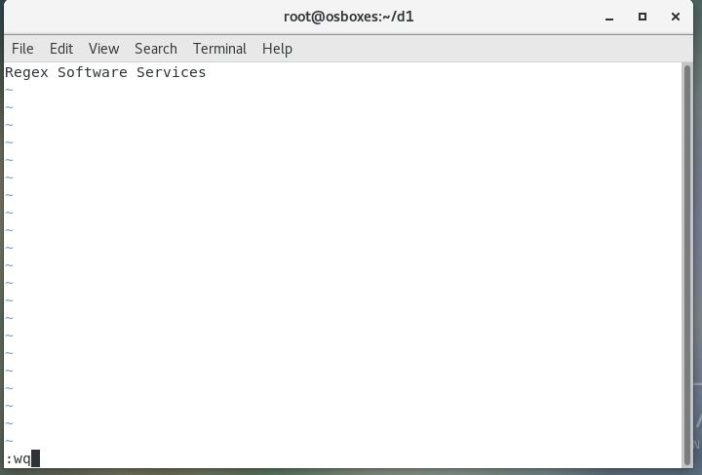

file3.txt:

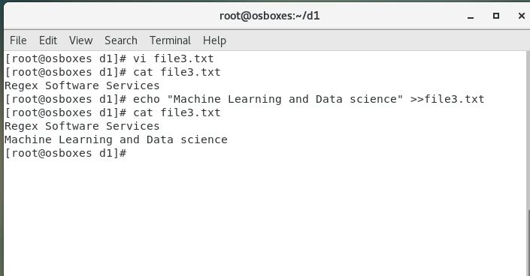

3)Install httpd and set up your own web server?

A.

* To install httpd use command "sudo yum install httpd ".

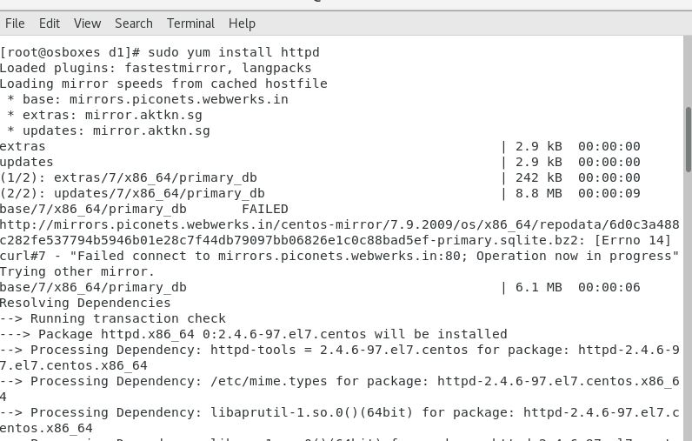

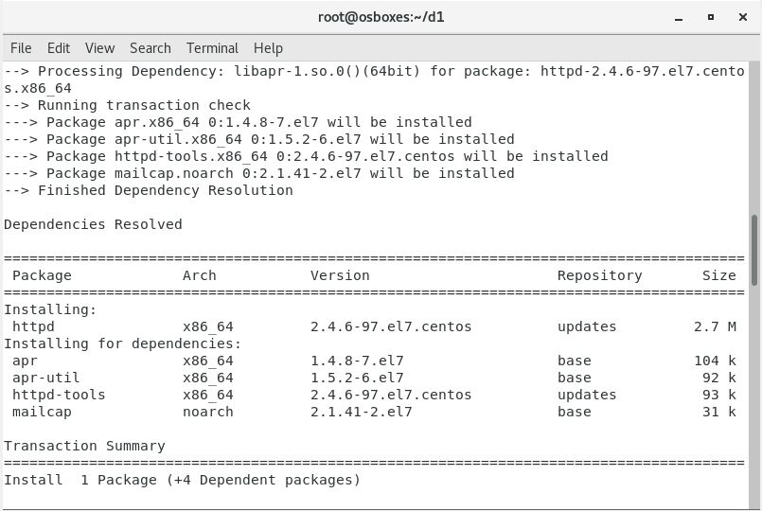

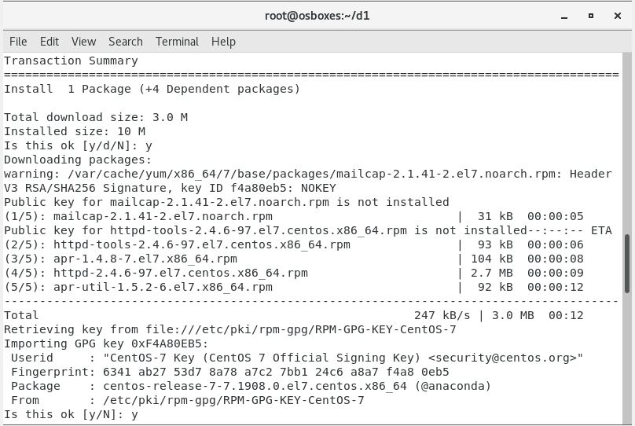

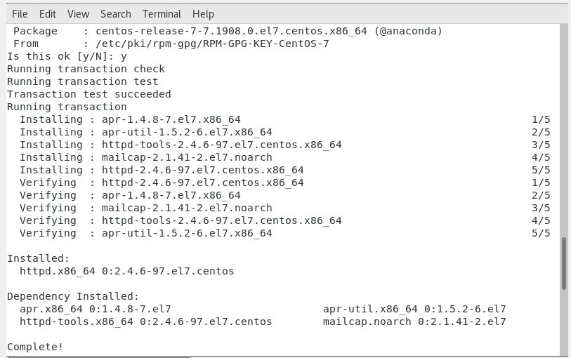

* To start httpd use command "systemctl start httpd"
* To enable httpd (By default disabled) use command "systemctl enable httpd"
* To check the status of httpd use command "systemctl status httpd".

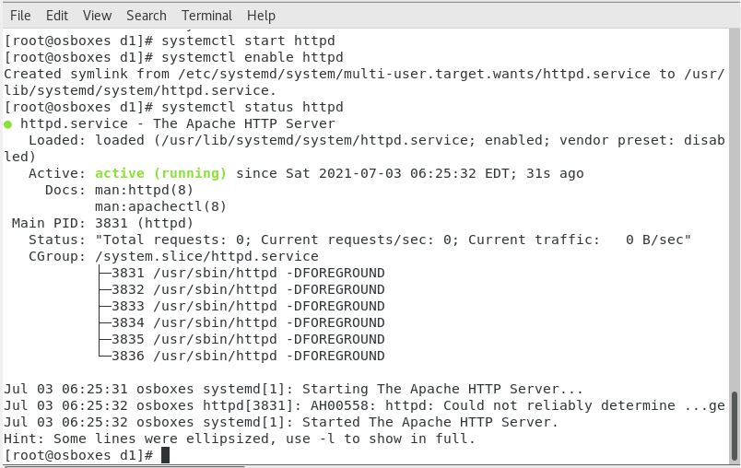

4.Copy some files from one Linux host to another Linux host via SCP?

A.

• Open both the hosts and rename

1. "host1" as "hostnamectl set-hostname host1" .
2. "host2" as"hostnamectl set-hostname host2".
3. After that use command "exec bash" to execute name change operation.

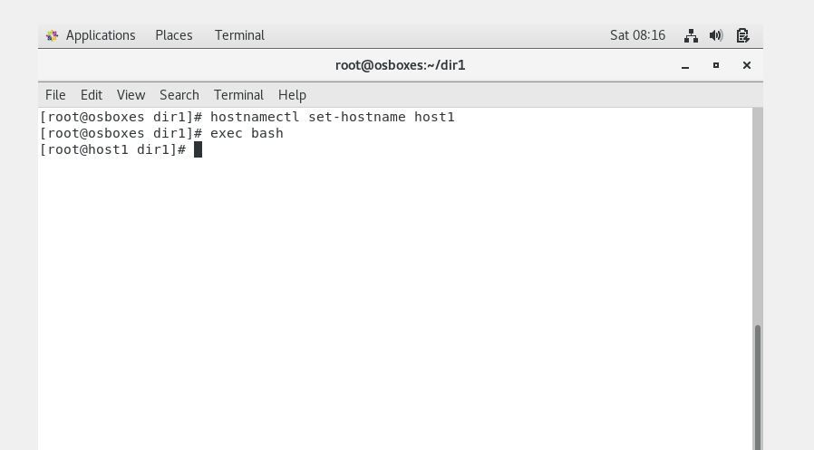

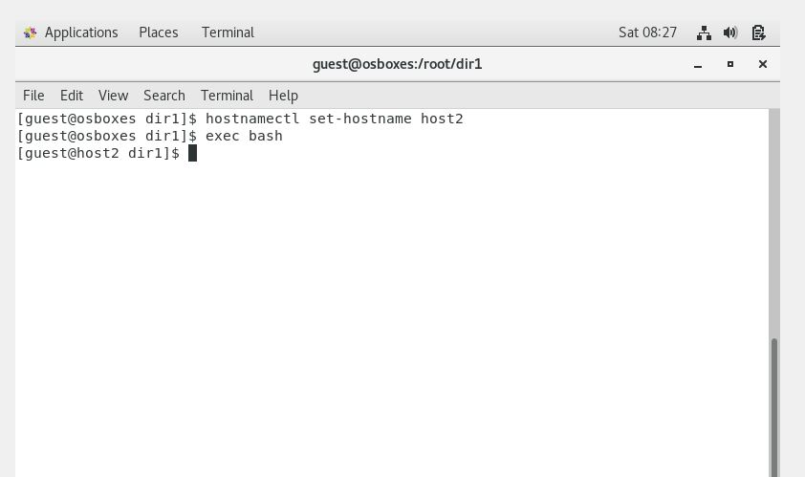  
• Check the ip address of both hosts using command "ifconfig | grep inet".

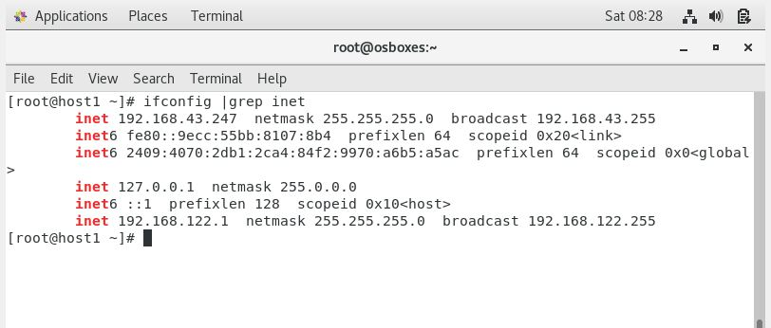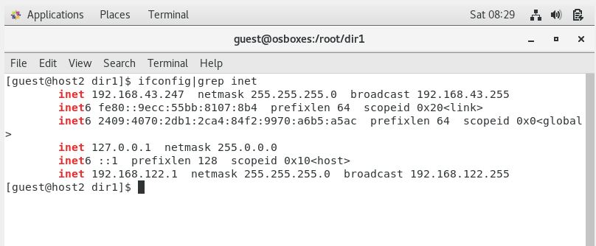

* Transfer the file from host1 to host2 using SCP.
* use command "scp filenameroot@(ipaddress of host2):/tmp".
* Password of host2 will be asked at that time.

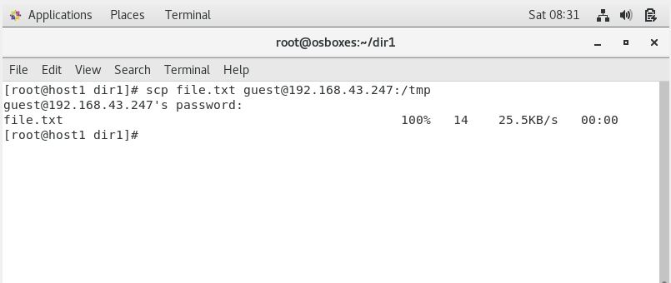

* Check the file in the host 2.

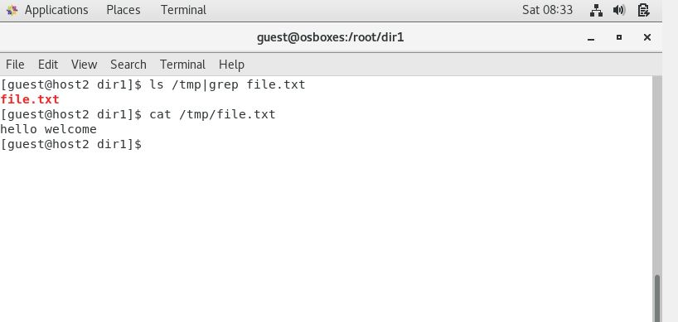

5) Create another VM and setup password less authentication

A)

• Create another VM can be setup by cloning the current VM.

* 1. Go to Oracle VM VirtualBox and right click on the current CentOS and select Clone.
  2. Don't change the default settings and just click Next
  3. Then choose Full Clone option from the current window.
  4. Click Clone. This will set another CentOS in your VirtualBox.

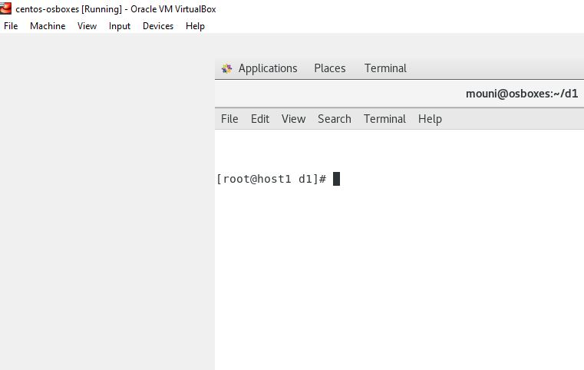

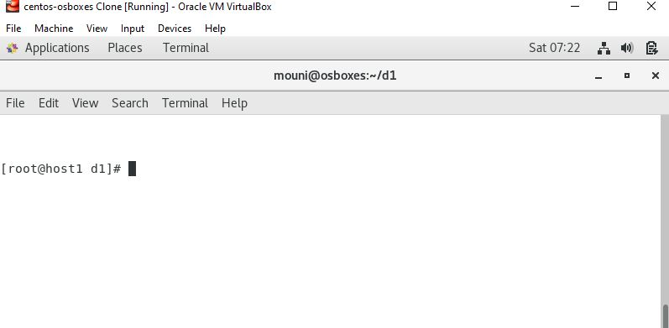

SETUP PASSWORD LESS AUTHENTICATION

* Generate the key using "ssh-keygen" in host 1 and enter authentication credentials.
* Then copy this key in host2 using command "ssh-copy-id root@(ip address of host2)".host2 will verify if it’s coming from the right source or not and if the key is matched, it means you are able to login. After that you need not to enter password while accessing host2 anymore.
* This is less authentication Password setup to access different host.

